Build a RESTful API using Node.js and Express

1. GET /users – Fetch all users
Request: GET http://localhost:8000/users
Expected Response:
- Status 200: Returns all users successfully.
- Status 404: Returns error if no users exist.
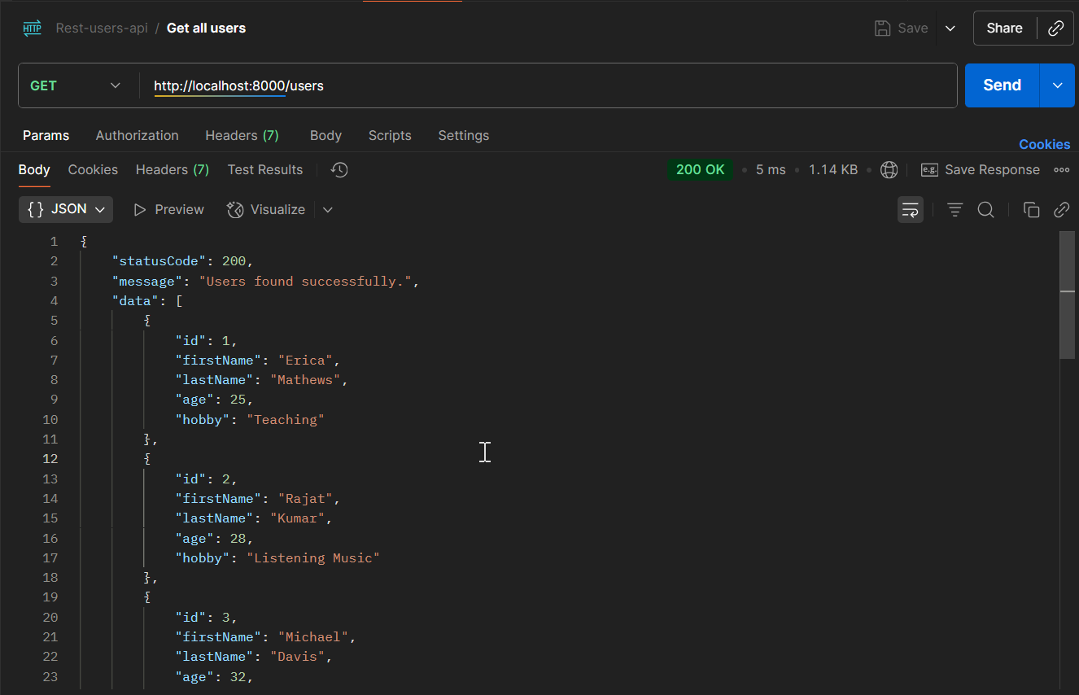
Fig1: Get all users
Description:
- This endpoint retrieves the complete list of users stored in memory.
- If the user’s array is empty, it returns a 404 with a message “Users not found. Please create a new user.”
- Otherwise, it returns 200 with all user objects in data.

2. GET /users/:id – Fetch user by ID
Request: GET http://localhost:8000/users/1
Expected Response:
- Status 200: Returns the user with the given ID.
- Status 404: Returns error if the user ID does not exist.

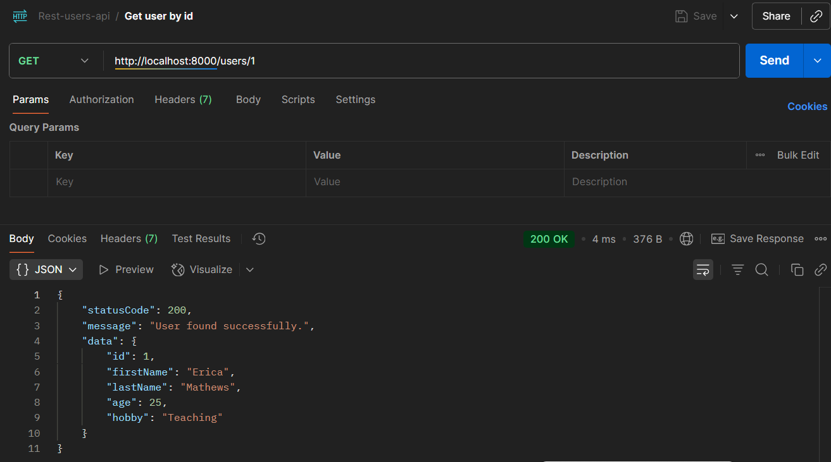
Fig2: Get user by id
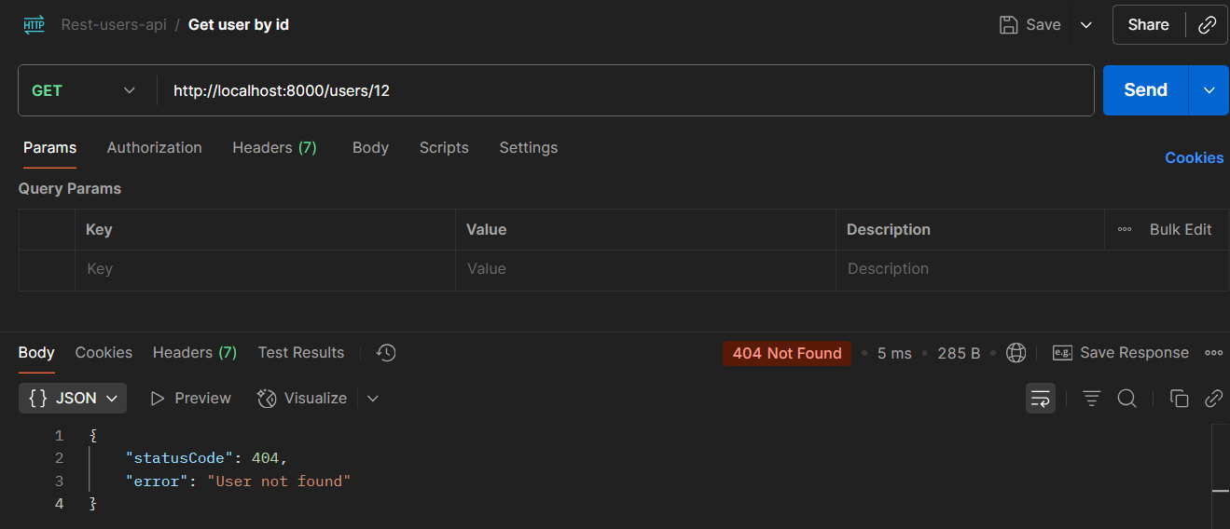
Fig3: User not found error
Description:
- This endpoint searches the users array for a user with the matching ID.
- If found, it returns 200 with the user object.
- If not found, it returns 404 with “User not found.”

3. POST /user – Create a new user
Request: POST http://localhost:8000/user
Content-Type: application/json
{
"firstName": "Sweety",
"lastName": "Kushwaha",
"age": 26,
"hobby": "Coding"
}

Expected Response:
- Status 201: Returns newly created user.
- Status 400: Returns validation error if input is invalid.

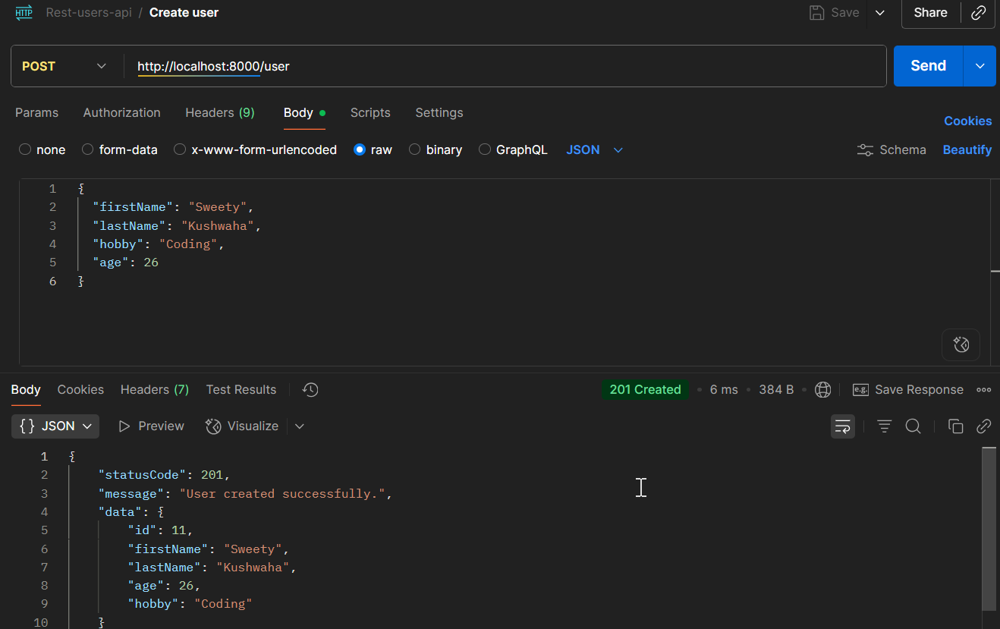
Fig4: Create new user

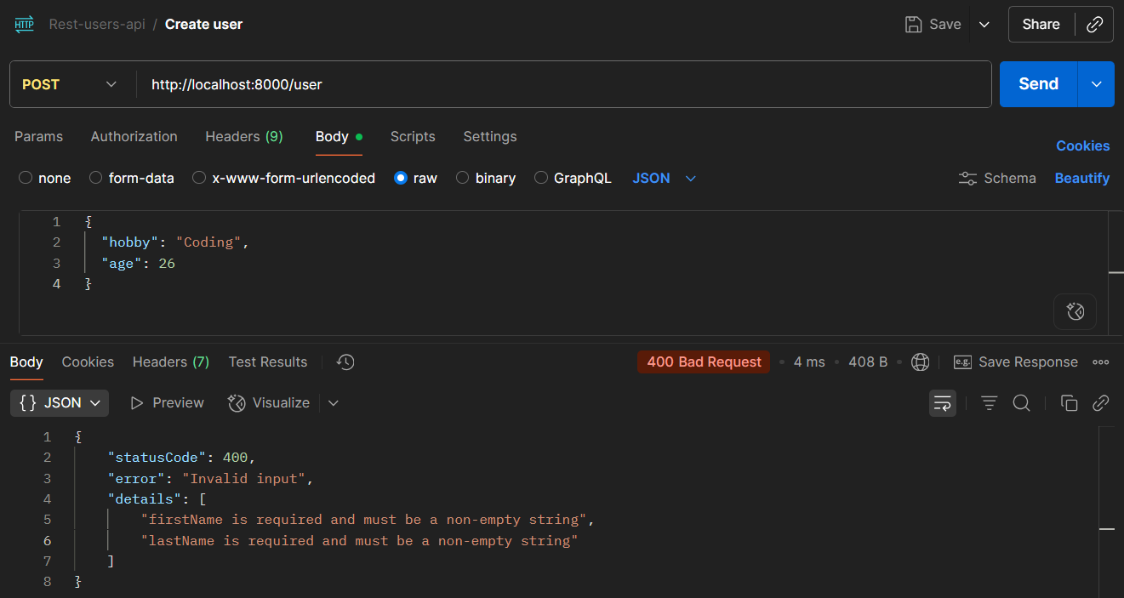
Fig5: Validation error for first name and last name

Description:
This endpoint creates a new user and automatically assigns a unique numeric ID.
Validation middleware ensures:
- firstName, lastName, hobby are non-empty strings if provided
- age is an integer between 0 and 120 if provided
Returns 201 with new user object if successful.

4. PUT /user/:id – Update existing user
Request: PUT http://localhost:8000/user/1
Content-Type: application/json
{
"age": 30,
"hobby": "Reading"
}

Expected Response:
- Status 200: Returns deleted user details.
- Status 404: Returns error if user ID does not exist.
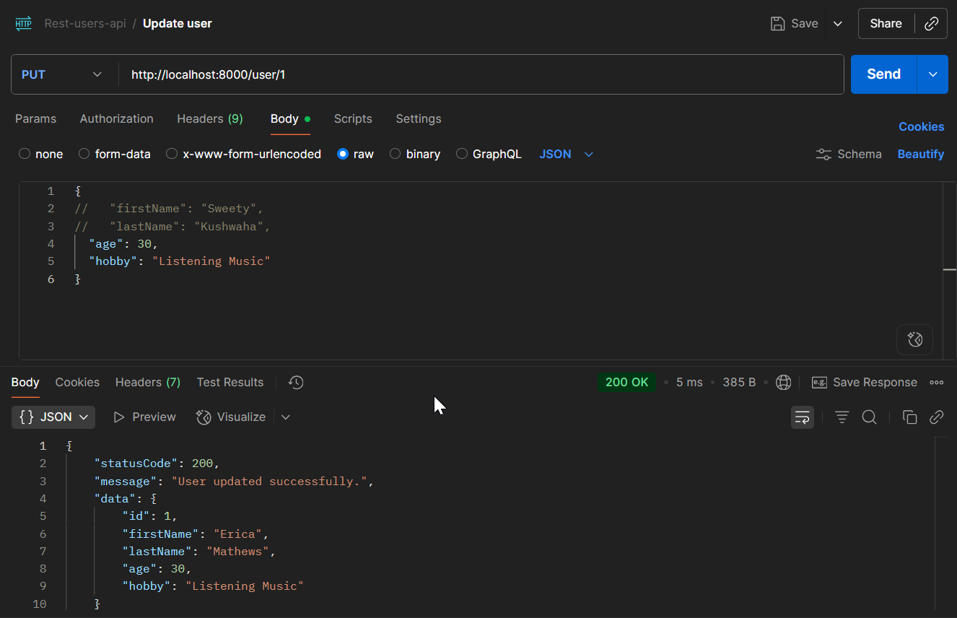
Fig6: Update existing user by id
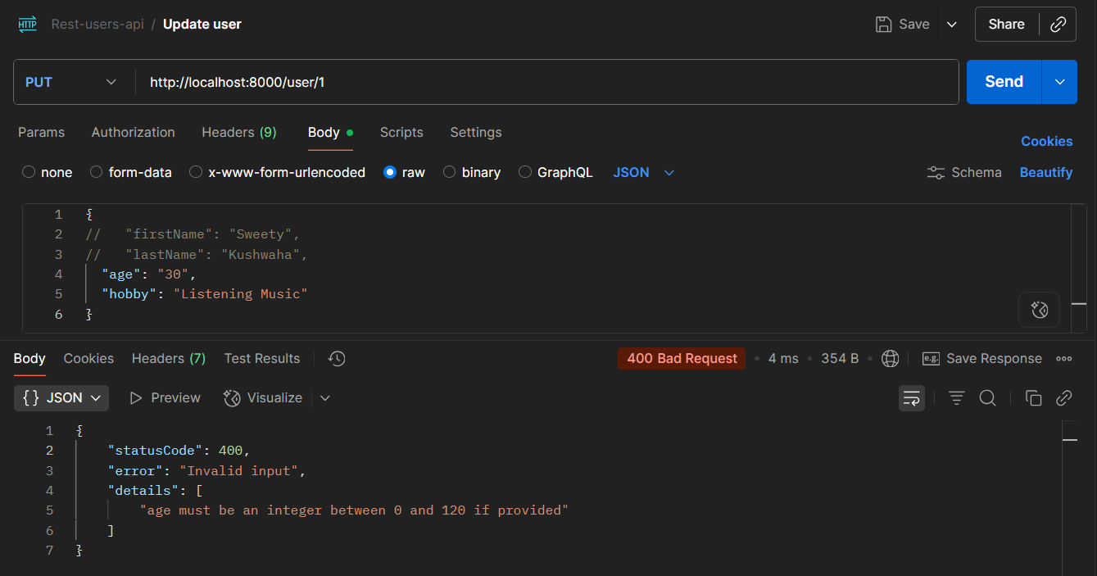
Fig7: Validation error for age
Description:
This endpoint updates an existing user.
- Only fields provided in the request are updated (optional fields).
- Validation middleware ensures provided fields are valid.
- Unspecified fields remain unchanged.
- Returns 200 with updated user object if successful.

5. DELETE /user/:id – Delete a user
Request: DELETE http://localhost:8000/user/10
Expected Response:
- Status 200: Returns deleted user details.
- Status 404: Returns error if user ID does not exist.
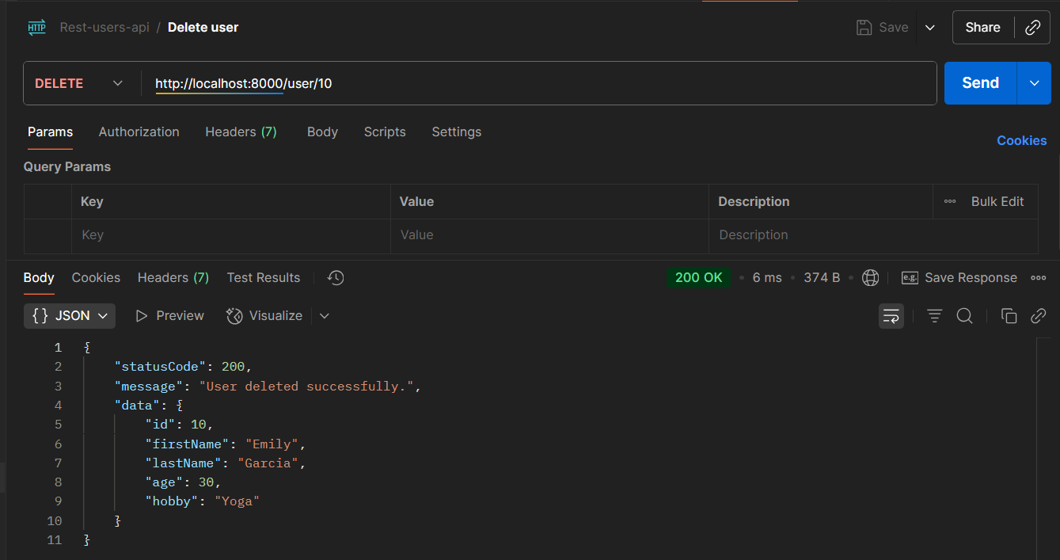
Fig8: Delete user by id
Description:
- This endpoint removes the user from the user’s array.
- If the user exists, it returns 200 with the deleted user data.
- If not, it returns 404 with “User not found.”

